BACKDROP SOURCE REPORT


By NIKita

About company
Backdropsource is a global provider of customized backdrops, banners, and exhibition display solutions. Founded in 2004, the company offers products such as SEG displays, Shell Scheme graphics, fabric backdrops, and trade-show booth solutions, helping businesses and event professionals create impactful visual branding experiences.
Products
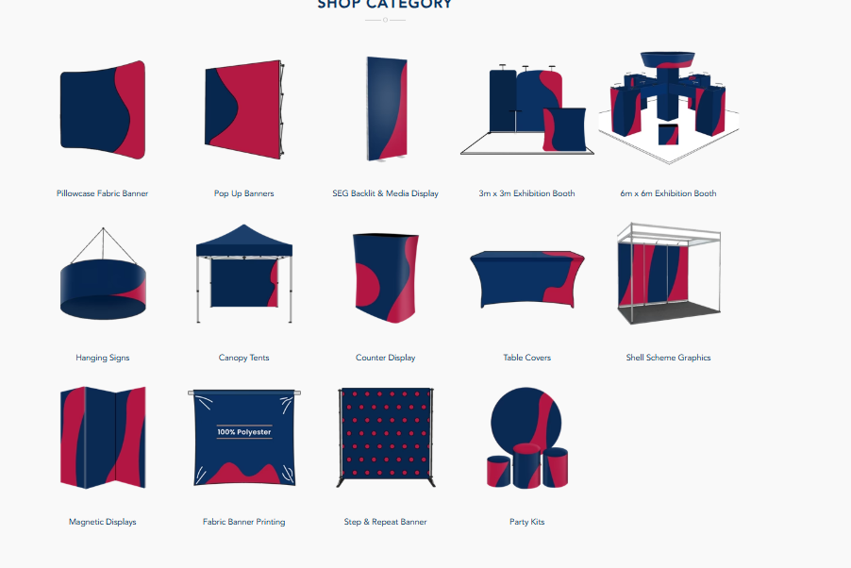

Analysis summary
The analysis covers two major product categories of Backdropsource: Shell Scheme and SEG Fabric Backlit Media Displays.
The Shell Scheme dataset contains 24 records, 6 SKUs, and 4 countries, while the SEG dataset contains 46 products with substantial variation in product pricing. Shell Scheme pricing shows a clear relationship between larger product dimensions and higher prices, whereas SEG pricing is highly varied, with premium modular lightbox products accounting for the highest prices.
Website traffic indicates approximately 16.1K monthly visits, but the 77.78% bounce rate suggests that a large proportion of visitors leave without further interaction. This indicates an opportunity to improve product-page engagement, navigation, and conversion.
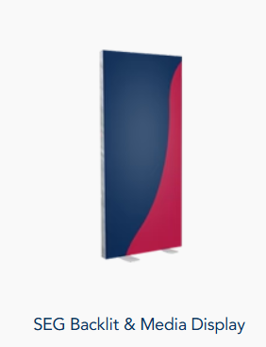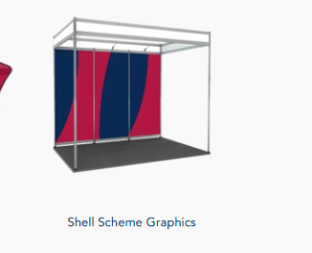

Shell Scheme Product Analysis
Metric | Finding
Records | 24
Unique SKUs | 6
Countries | 4
Missing Values | None
Duplicate Records | None
Highest-priced SKU | SS-EG-20X10
Lowest-priced SKU | SS-FULL
Currency | USD, GBP, AUD, INR
The Shell Scheme products demonstrate a strong size-price relationship. Larger exhibition spaces generally have higher prices, with SS-EG-20X10 being the highest-priced SKU across all markets.
However, prices across countries should not be compared directly because they are represented in different currencies. Currency conversion is required for meaningful international price comparison.

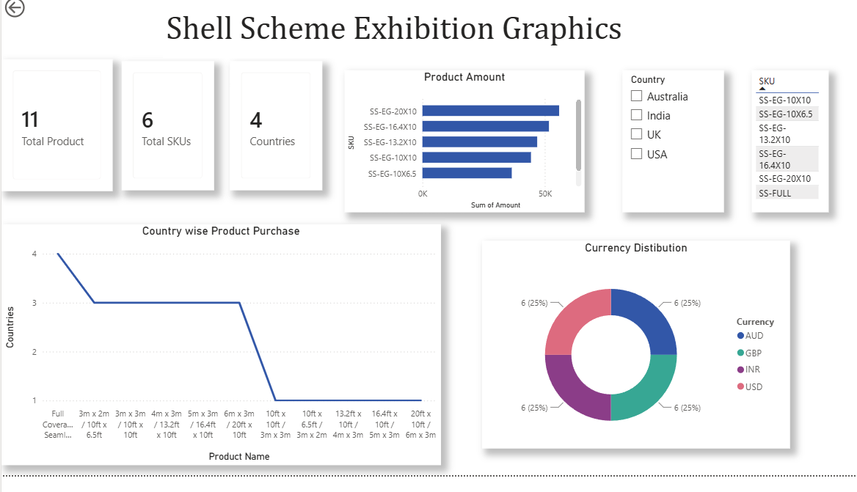

SEG Product Analysis
Metric | Finding
Products | 46
Minimum Price | ~25.9K
Maximum Price | ~1.25M
Average Price | ~230.75K
Median Price | ~150.07K
Price Distribution | Right-skewed
Highest-priced category | SEG Modular Lightbox Display
Key insight
SEG pricing has a much wider range than Shell Scheme pricing. A small number of high-priced modular lightbox products significantly increase the average price.
The difference between the average price (~230.75K) and median price (~150.07K) indicates that high-value products are pulling the average upward.
These products should not automatically be considered errors or removed as outliers because they may represent genuine premium products.
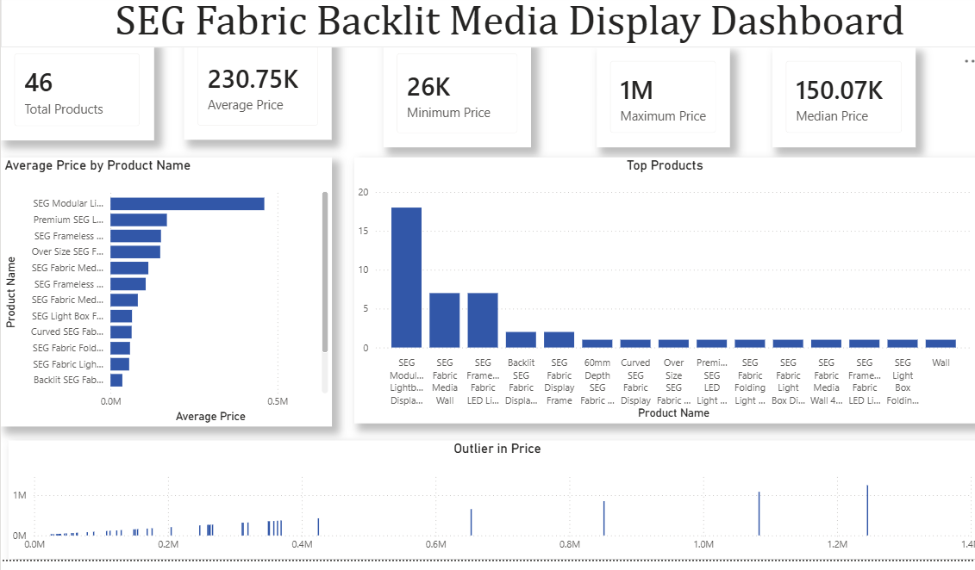
Website Performance – 5 Key Metrics
KPI | Current Value | Interpretation
Monthly Visits | 16.1K | Good volume of website traffic and potential customer reach
Daily Visitors | 530 | Consistent daily visitor flow
Pages / Visit | 2.14 | Visitors view relatively few pages per session
Average Visit Duration | 2:05 min | Moderate engagement, but there is room for improvement
Bounce Rate | 77.78% | High bounce rate; indicates many visitors leave without further interaction

Key Website Insights
The website receives approximately 16.1K monthly visits, but the 77.78% bounce rate is a major concern.
This suggests that traffic is not translating effectively into deeper website engagement.
2. Low page exploration
Visitors view approximately 2.14 pages per visit.
This indicates an opportunity to improve internal navigation and encourage visitors to explore related products.
3. Moderate visit duration
The average visit duration is approximately 2 minutes 5 seconds.
This means visitors are spending some time on the website, but stronger product discovery and calls-to-action could encourage longer engagement.

4. Traffic source data should be added
The current data does not show whether visitors are coming from:
- Organic Search
- Paid Search
- Direct
- Social Media
- Referral
- Email
This is important because the company should invest more in the channels that generate high-quality visitors and conversions, rather than focusing only on traffic volume
5. Conversion tracking is essential
The current data tells us how many people visit the website, but not how many actually become customers.
Therefore, conversion rate should be one of the primary KPIs in the next version of the dashboard.
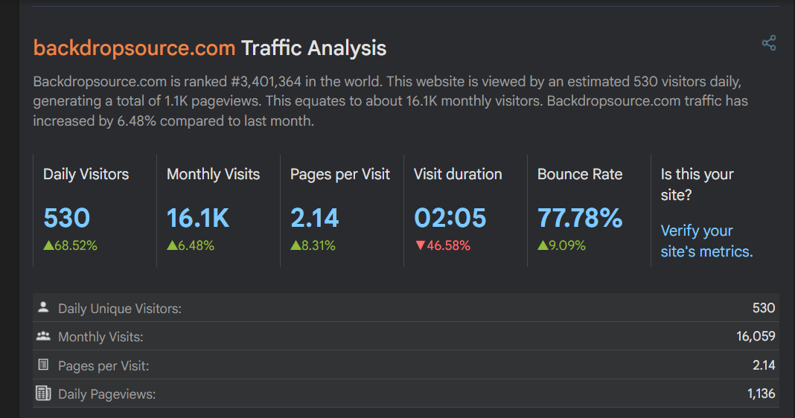

Data-Driven Actions to Increase Sales
Action 1 — Reduce the High Bounce Rate
The 77.78% bounce rate should be a major priority.
Improve product landing pages by adding:
- Clear "Get a Quote" / "Buy Now" buttons
- Product pricing or starting price
- High-quality product images
- Dimensions and specifications
- Related products
- Customer reviews
- Clear shipping information
- Strong product descriptions
Expected impact:
Lower bounce rate → higher product exploration → more enquiries → higher conversion potential.

Action 2 — Promote High-Value SEG Products Strategically
The SEG dataset shows that SEG Modular Lightbox Display products command significantly higher prices, with some products exceeding 1M.
Instead of treating these products only as expensive items, position them as premium solutions.
For example:
Premium SEG Lightbox → Custom Exhibition Display → Get a Quote
Use targeted landing pages and promotional campaigns for high-value customers.
At the same time, use lower-priced SEG and Shell Scheme products as entry-level options.
This creates a pricing ladder:
Entry-Level → Mid-Range → Premium
This can help capture customers with different budgets.

Action 3 — Use Traffic Sources to Optimize Marketing Spend
Once traffic-source data is available, compare:
Traffic Source → Visitors → Product Views → Add to Cart/Quote → Conversion → Revenue
For example:
Traffic Source | Visitors | Conversion Rate | Revenue
Organic | — | — | —
Paid Search | — | — | —
Social | — | — | —
Direct | — | — | —
Referral | — | — | —
Invest more in channels that produce conversions and revenue, not simply the highest number of visitors.

Final Recommendations
The analysis suggests three major priorities:
Improve website conversion: The combination of 16.1K monthly visits and 77.78% bounce rate indicates that converting existing traffic is a major opportunity.
Create product-based pricing strategies: Use Shell Scheme's size-price relationship and SEG's premium pricing structure to create entry, mid-range, and premium product segments.
Implement conversion and traffic-source tracking: Website traffic alone is insufficient to measure sales performance. Track traffic source, product views, add-to-cart/quote requests, conversion rate, and revenue in Power BI.
Overall Business Conclusion
Backdropsource has a strong product portfolio with significant opportunities in both standard and premium display segments. The main growth opportunity is not only increasing website traffic but improving the conversion of existing traffic into product enquiries and sales. A combination of better product-page experience, premium product targeting, and channel-level conversion tracking can help improve sales performance.

Links
https://github.com/nikitaphartiyal/Backdropsource-
https://hypestat.com/info/backdropsource.com
https://www.backdropsource.in/collections/seg-fabric-backlit-media-display
https://www.backdropsource.in/collections/shell-scheme-exhibition-graphics

